Report

# Language – English

**Analysis:**

**1.**

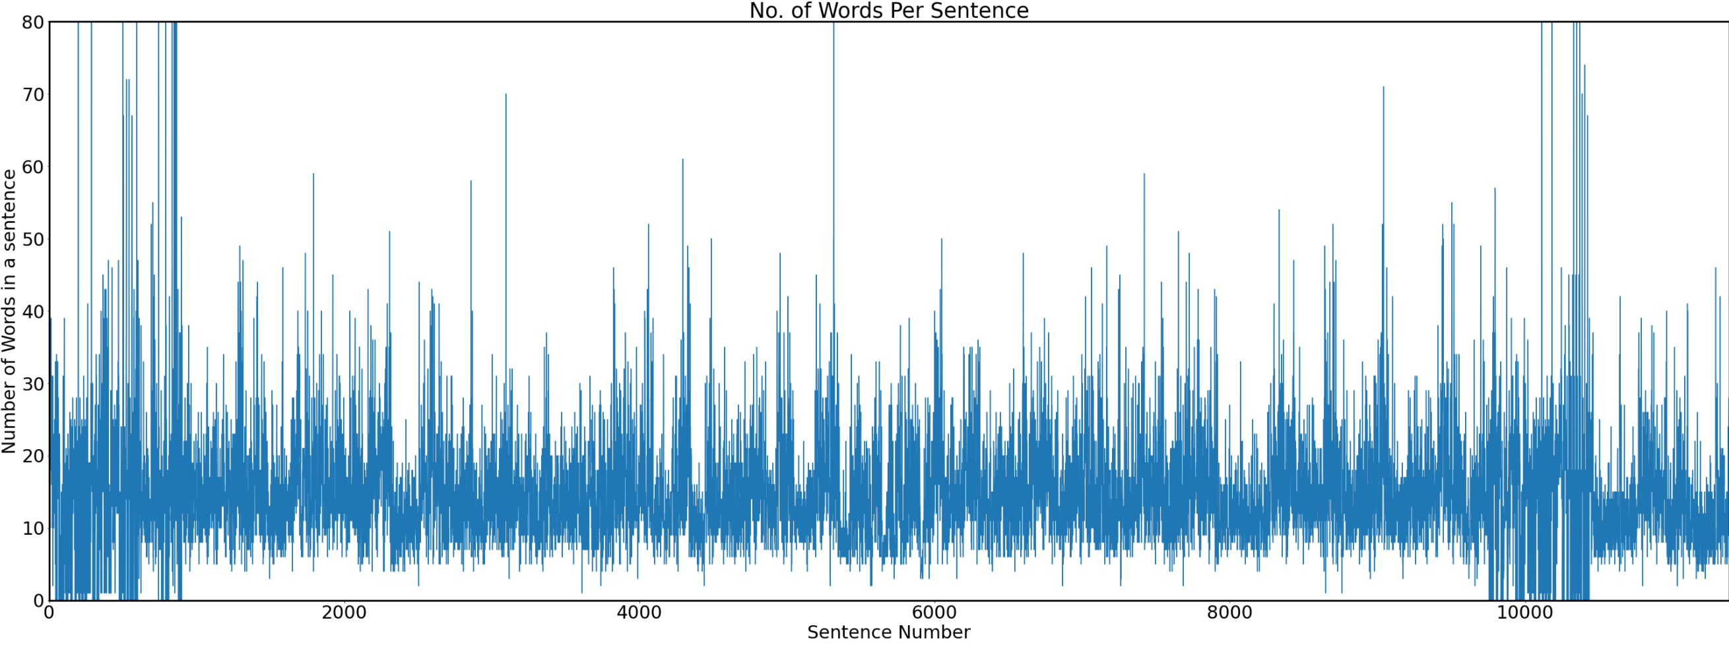

**Here in some sentences the number of words have exceed 80 which we know are not right. It might be because the data I got from the website, there the subsequent sentence might be starting without a spacebar.**

**Reason 2: Might be it might have caught some foreign unrecognized text or img in txt form with may have cause the increase in the number of words.**

**2.**

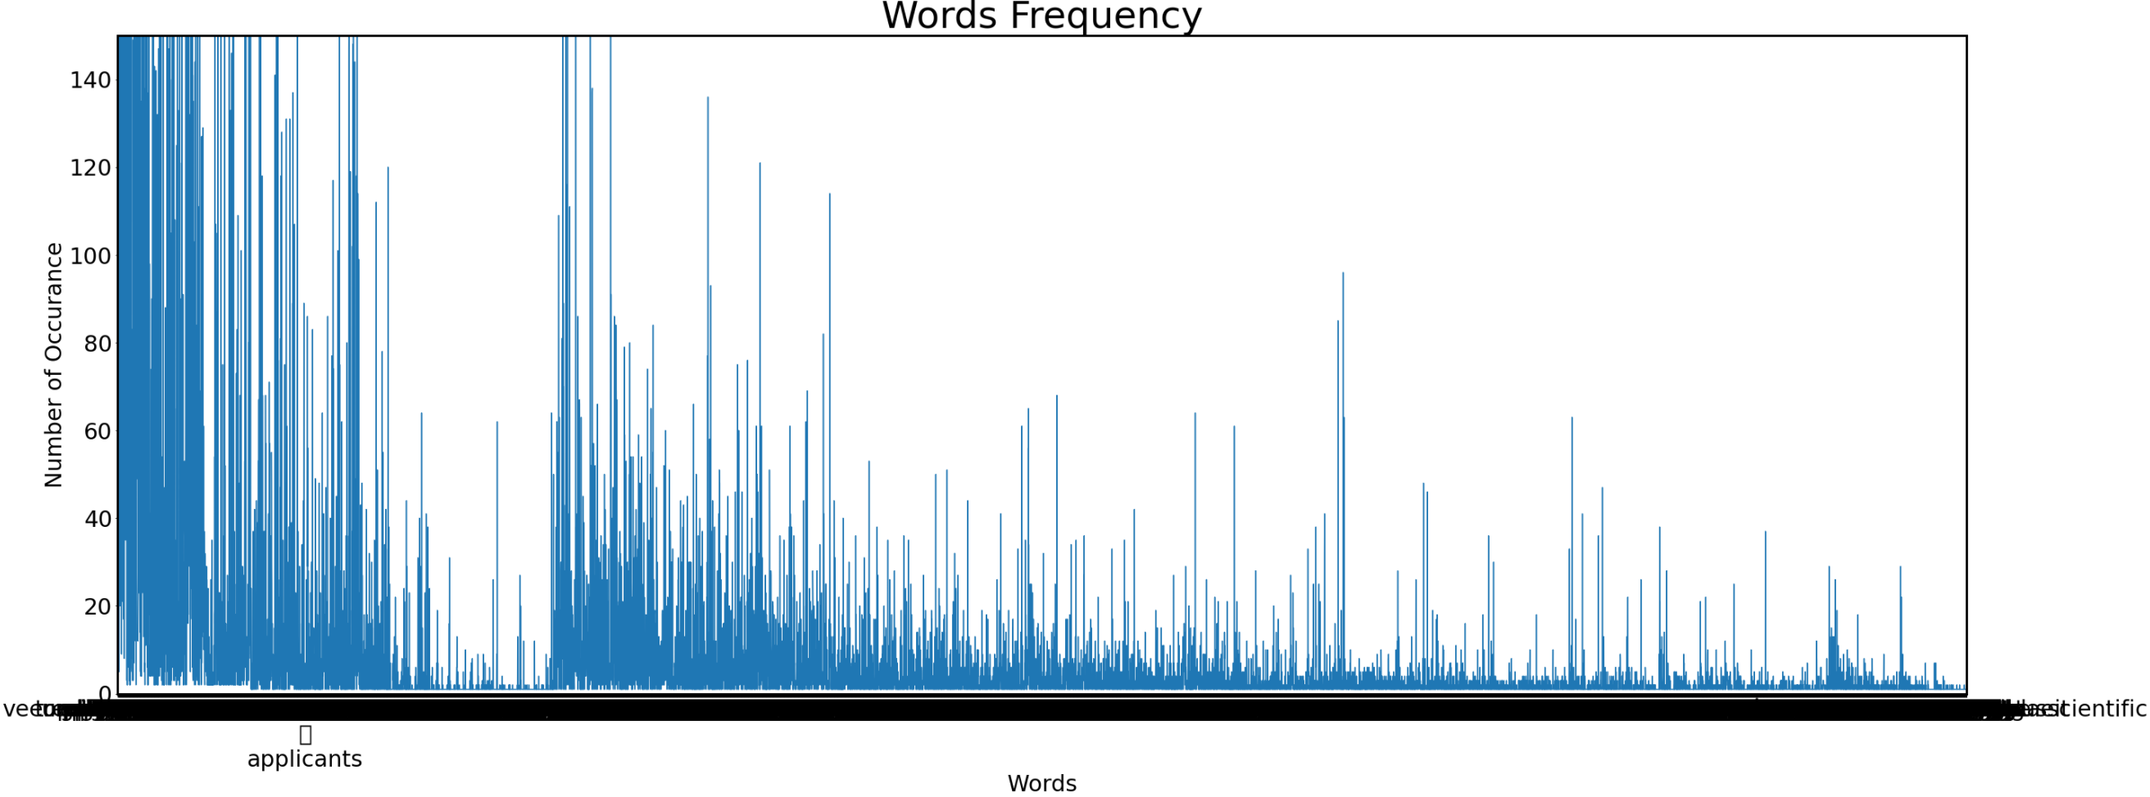

**Here is just the Word Frequency graph i.e. which word occurred how many times in my corpus.**

**3.**

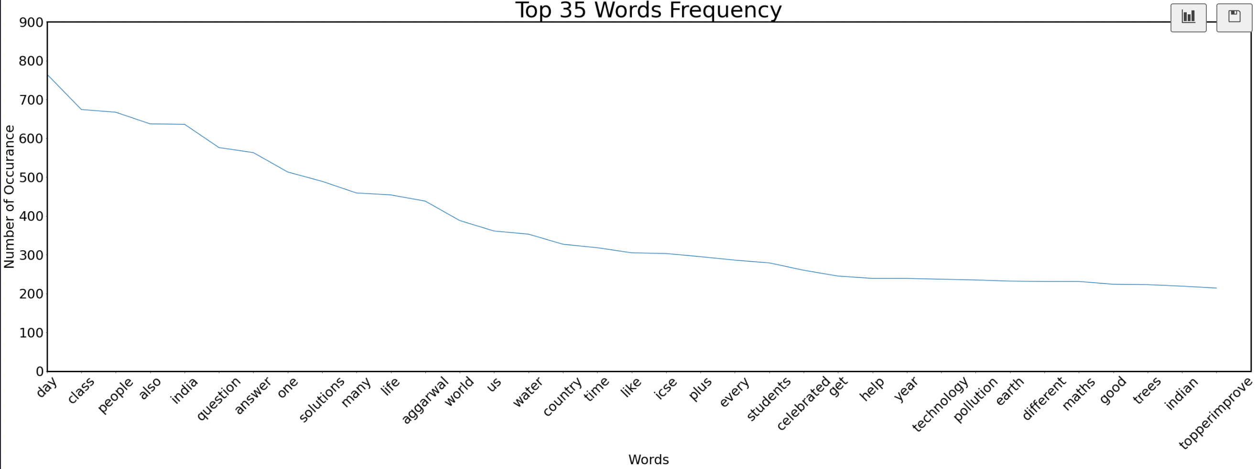

**These are the top 35 words that occurred the most number of times in my corpus after removing the stopwords and cleaning.**

**4.**

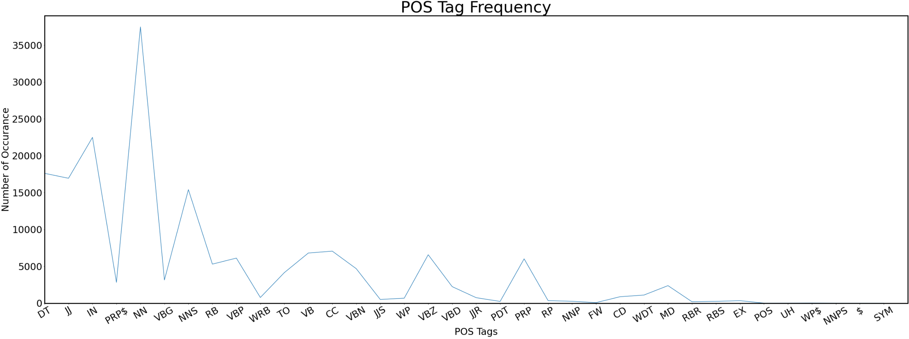

**These are the POS Tag Frequency that the words are from in the corpus.**

**5.**

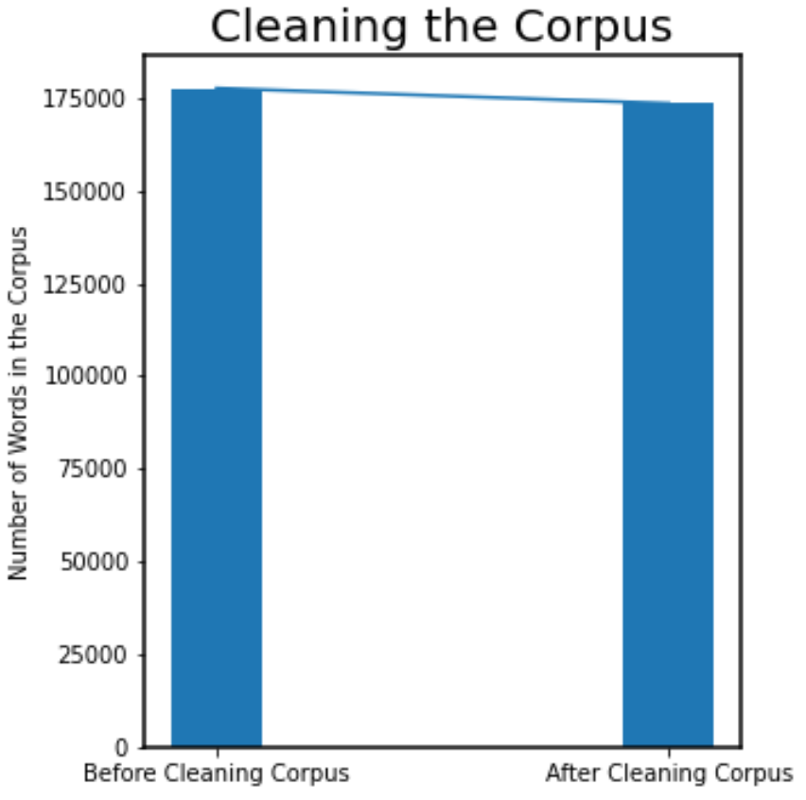

**Graph of number words in the corpus before and after cleaning the corpus.**

**6.**

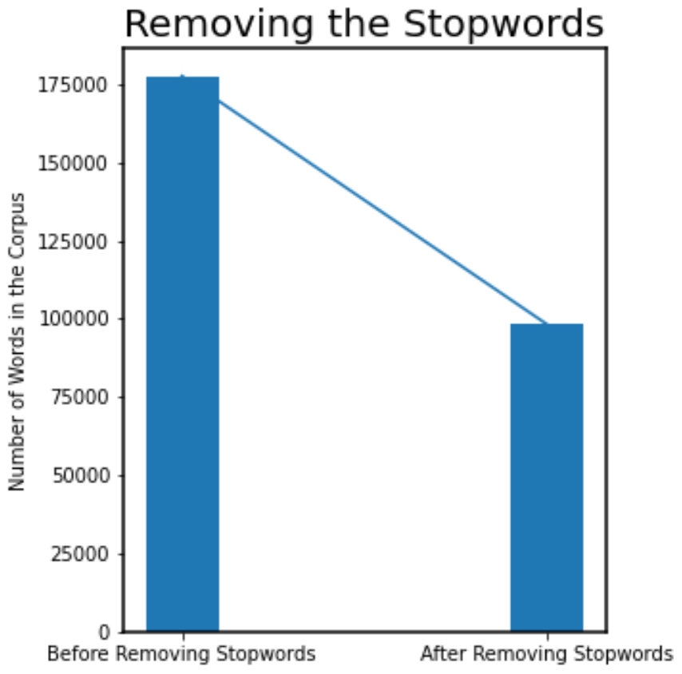

**Number of words in the corpus before and after removing the Stopwords form the corpus**

**7.**

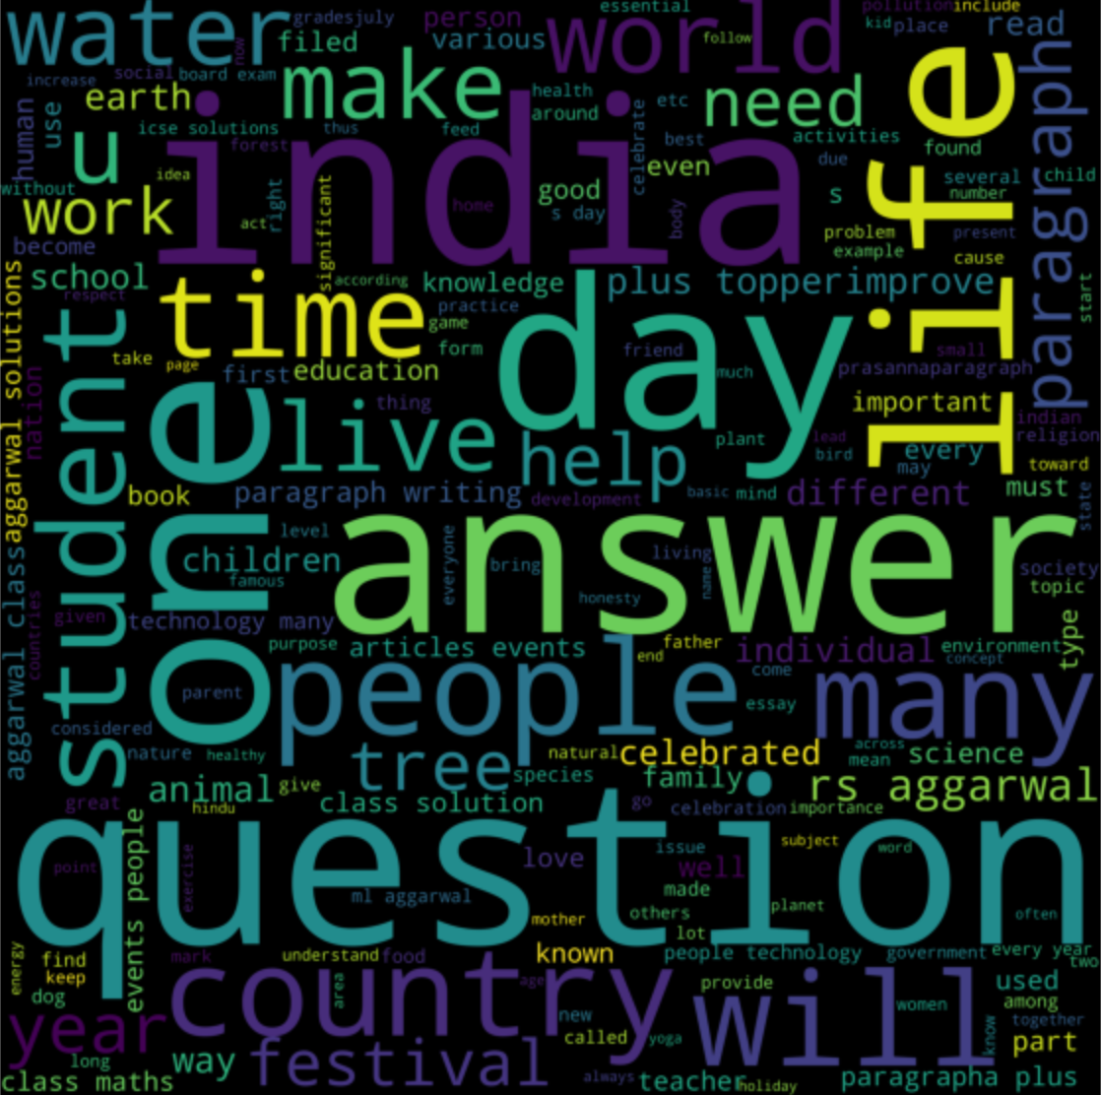

**I made this using the WordCloud Library**

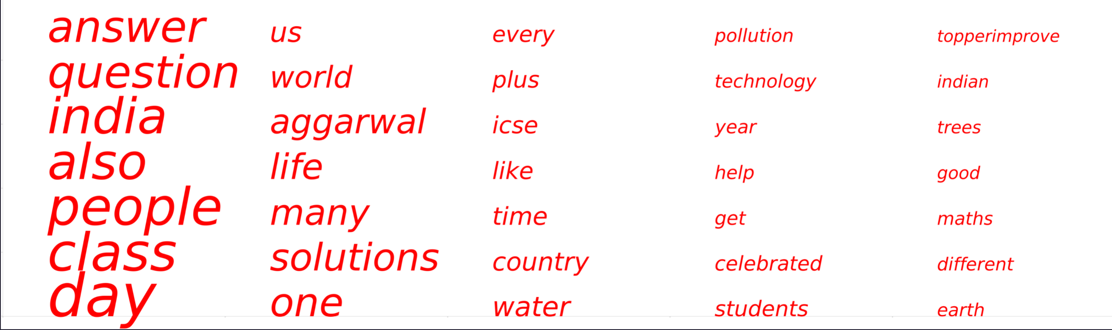

This is made using only MatplotLib using the number of Occurrence of these words and assigned a relative font size to these words and pointing them in this space. No Addition Library is used here.

**I took the first 35 words with most occurance in the corpus for the Word Cloud as it Represent the main Chunk of the corpus and hence they will represent the corpus in the wordcloud**

Here what I did is I assigned the font-Size of the Text as a Function of Frequency relative to the size of the plane printing the text.

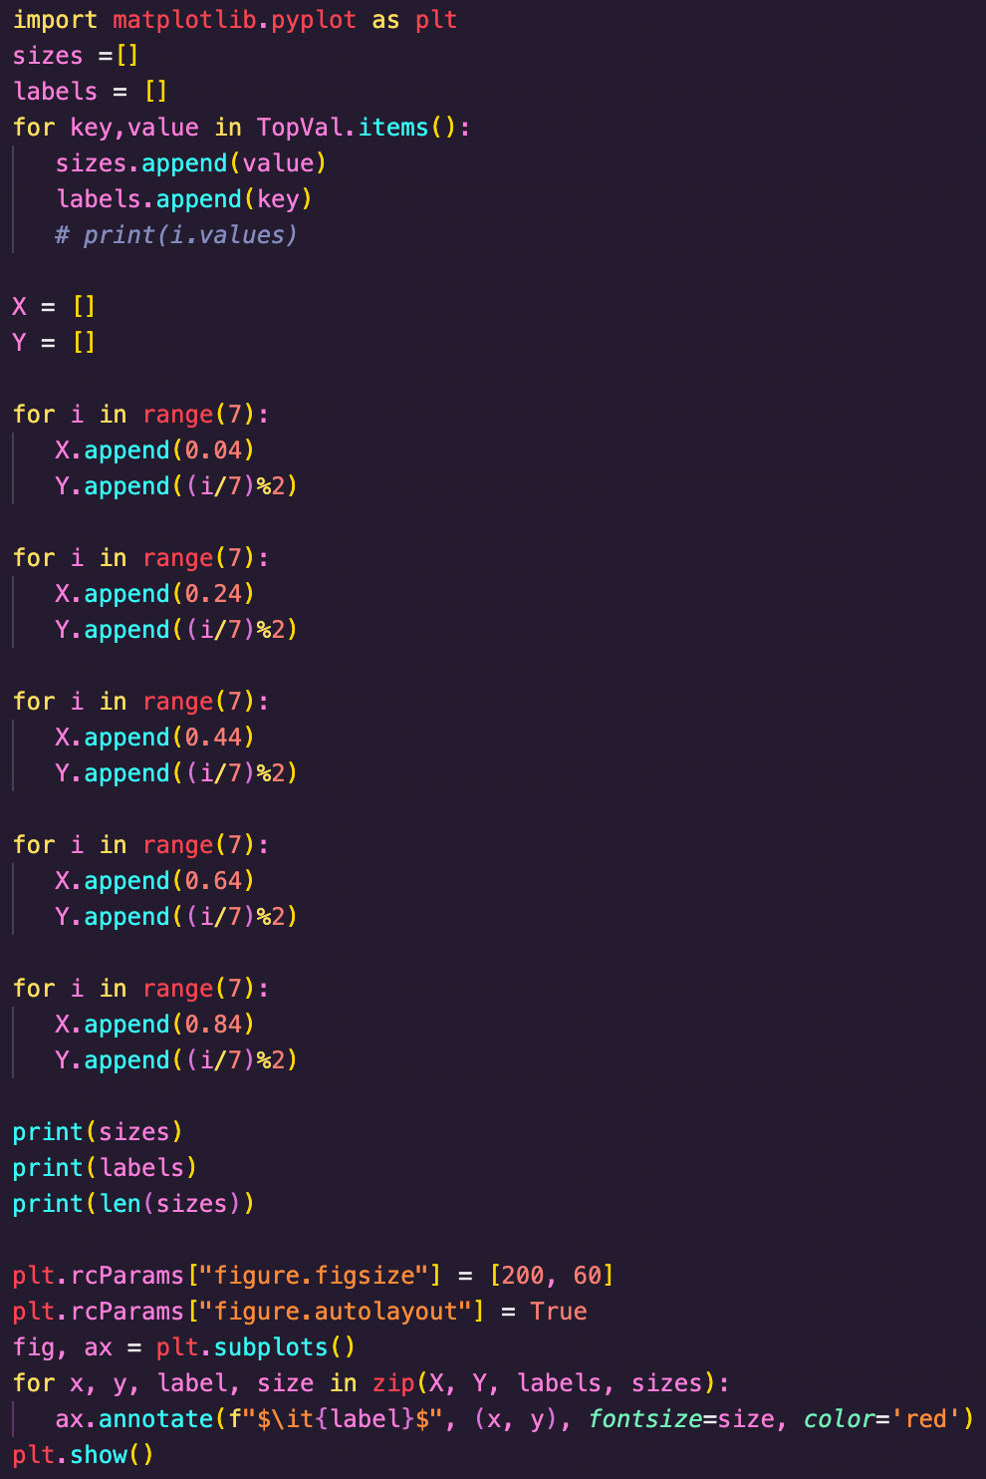

**Overview of my Code:**

**Now I will explain how I did the processing**

**Step1: I select a Website and scrape the text in <p> in that page only.**

**Step2: I collected all the links in that website and iterated throught all links (Recursively i.e. links will be added with each link iteration) and added to the corpus.**

**Step3: I did Cleaning i.e. removing Extra Spaces, Puntuation marks, and changed everything to lower case in the corpus**

**Step 4: I Tokenized the corpus into Sentences without Using any library by some rules I thought.**

**Step 5: Then I Tokenized into Words without any Library just by splitting by ‘ ’**

**Step 6: I cleaned the Words and Sentence again as I tokenized old corpus .**

**Step 7: I did POS tagging using the NLTK Library**

**Step 8: I removed Stopwords by iterating though each word and comparing string with the stopword list.**

**Step 9: Then I did Stemming and Lemmatization using the NLTK Library.**

**Step 10: Then I made Graphs mentioned above.**

# Language – Hindi

1.

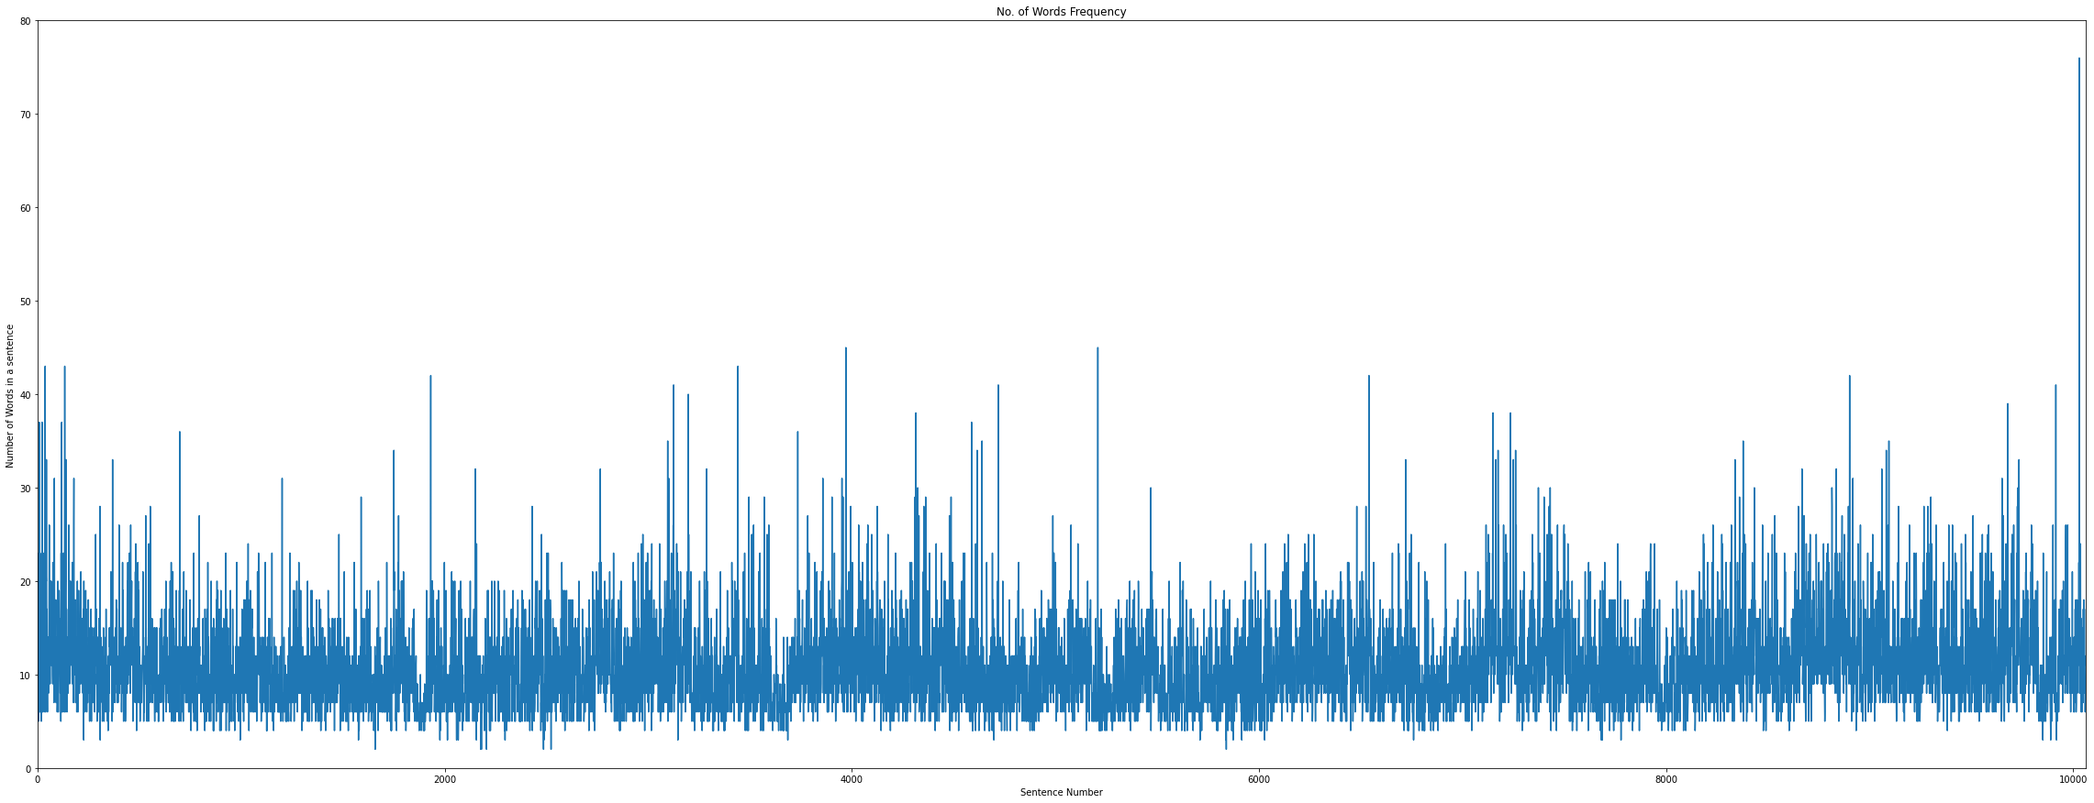

This is the graph on the Number of words in each sentence. From here we can observe that the average number of words in a sentence in our corpus is between 10-20 words and some sentences are even about 40 words long.

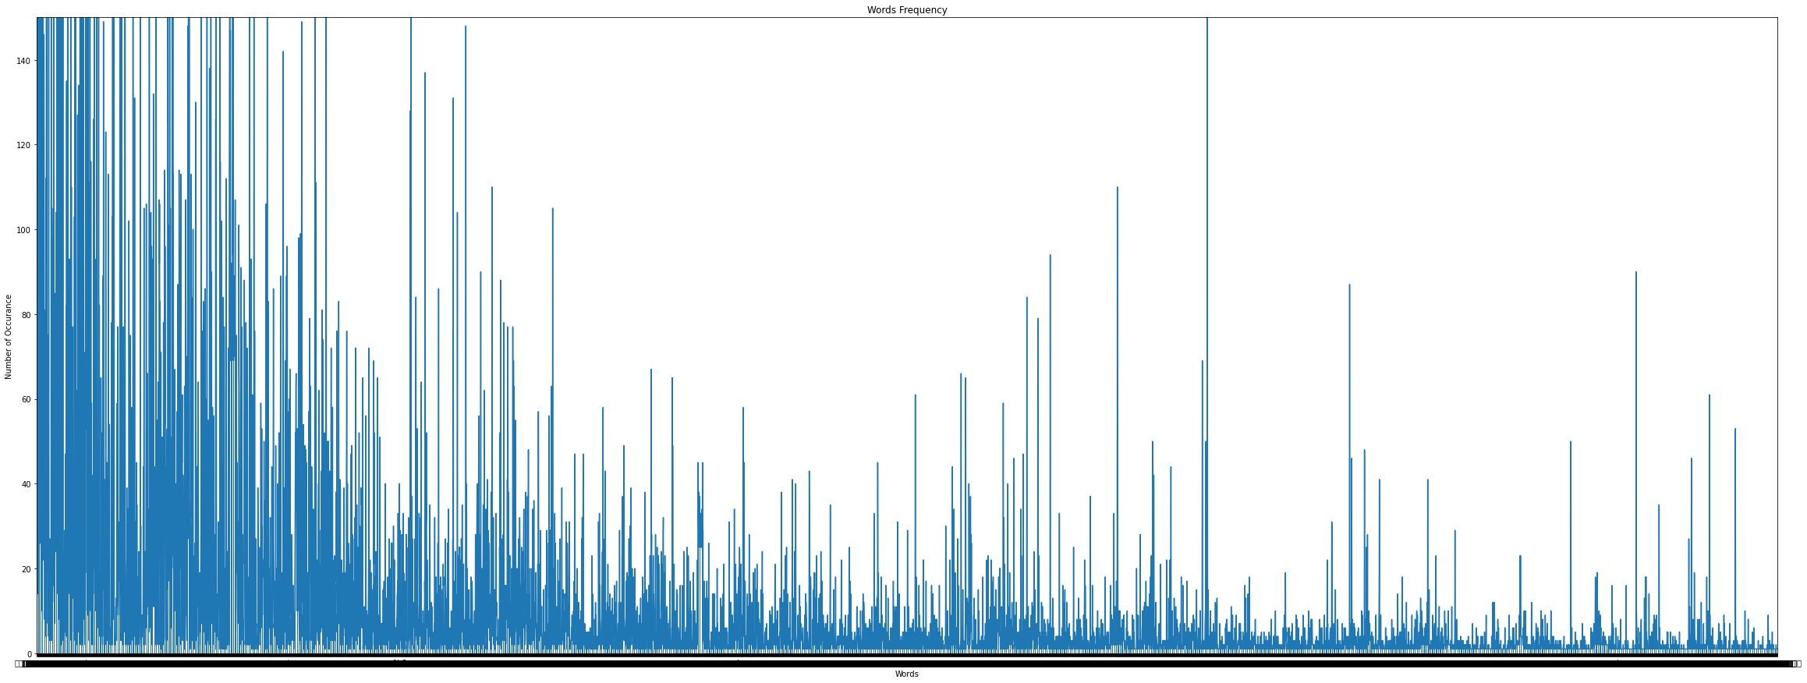

This is the graph of word frequency i.e. how many times every word occurred in the corpus.

Here the words that occurred most number of times are mentioned in another graph below.

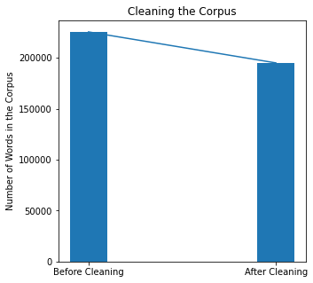

This is the number of Words in the Corpus before and after Cleaning the Corpus. As we can see, after cleaning the corpus, about 10% of the words have been removed which means many symbols, foreign character, punctuation marks were earlier treated as a word.

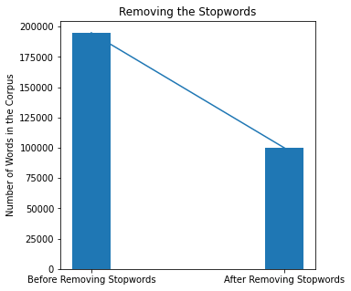

On Cleaning the stopwords, 50% of the word vanished which tells us that in Hindi Language there is an extensive use of Stopwords in most of the sentences.

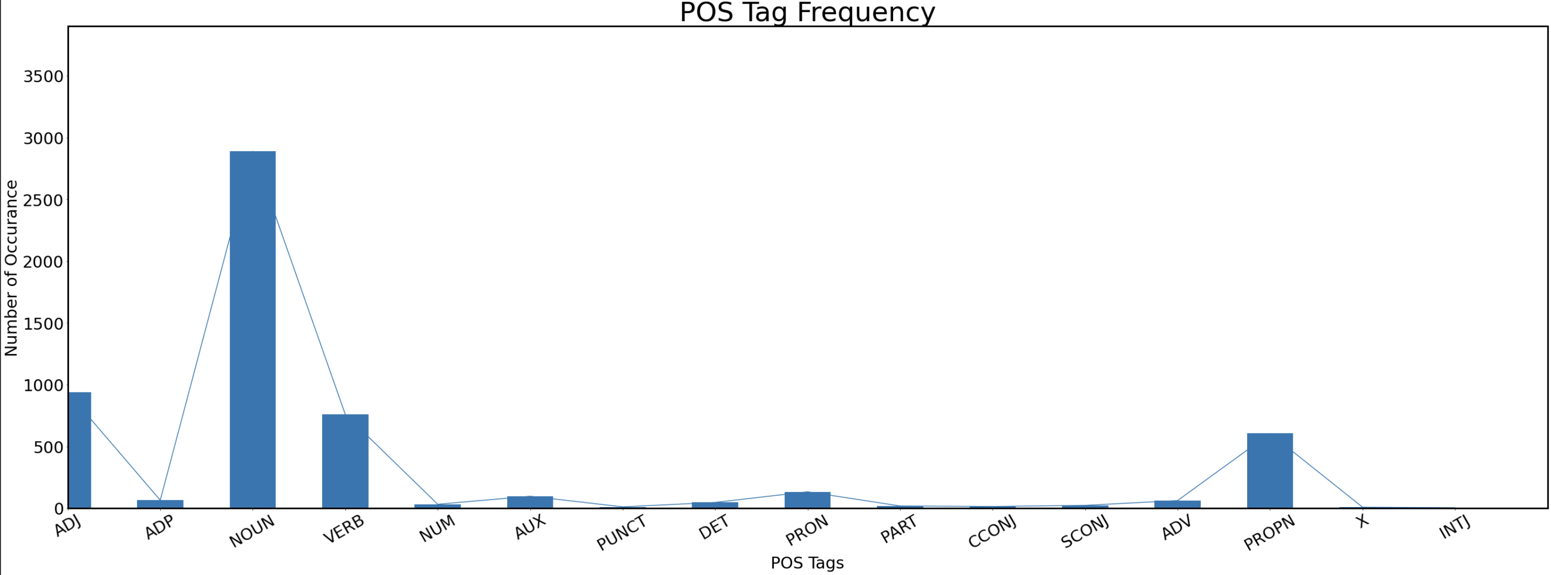

This is the POS-Tag Frequency graph and as we can see, the library was unable to recognize some of the text, but among the recognized text, NN (Noun Singular) is used the most and then comes the PUNC (Punctuations) which is true for the Hindi language due to their extensive use in Hindi sentences.

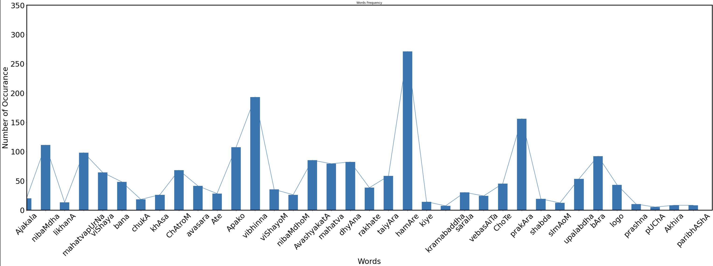

This is the Graph of First 35 Word’s Frequency in the Corpus

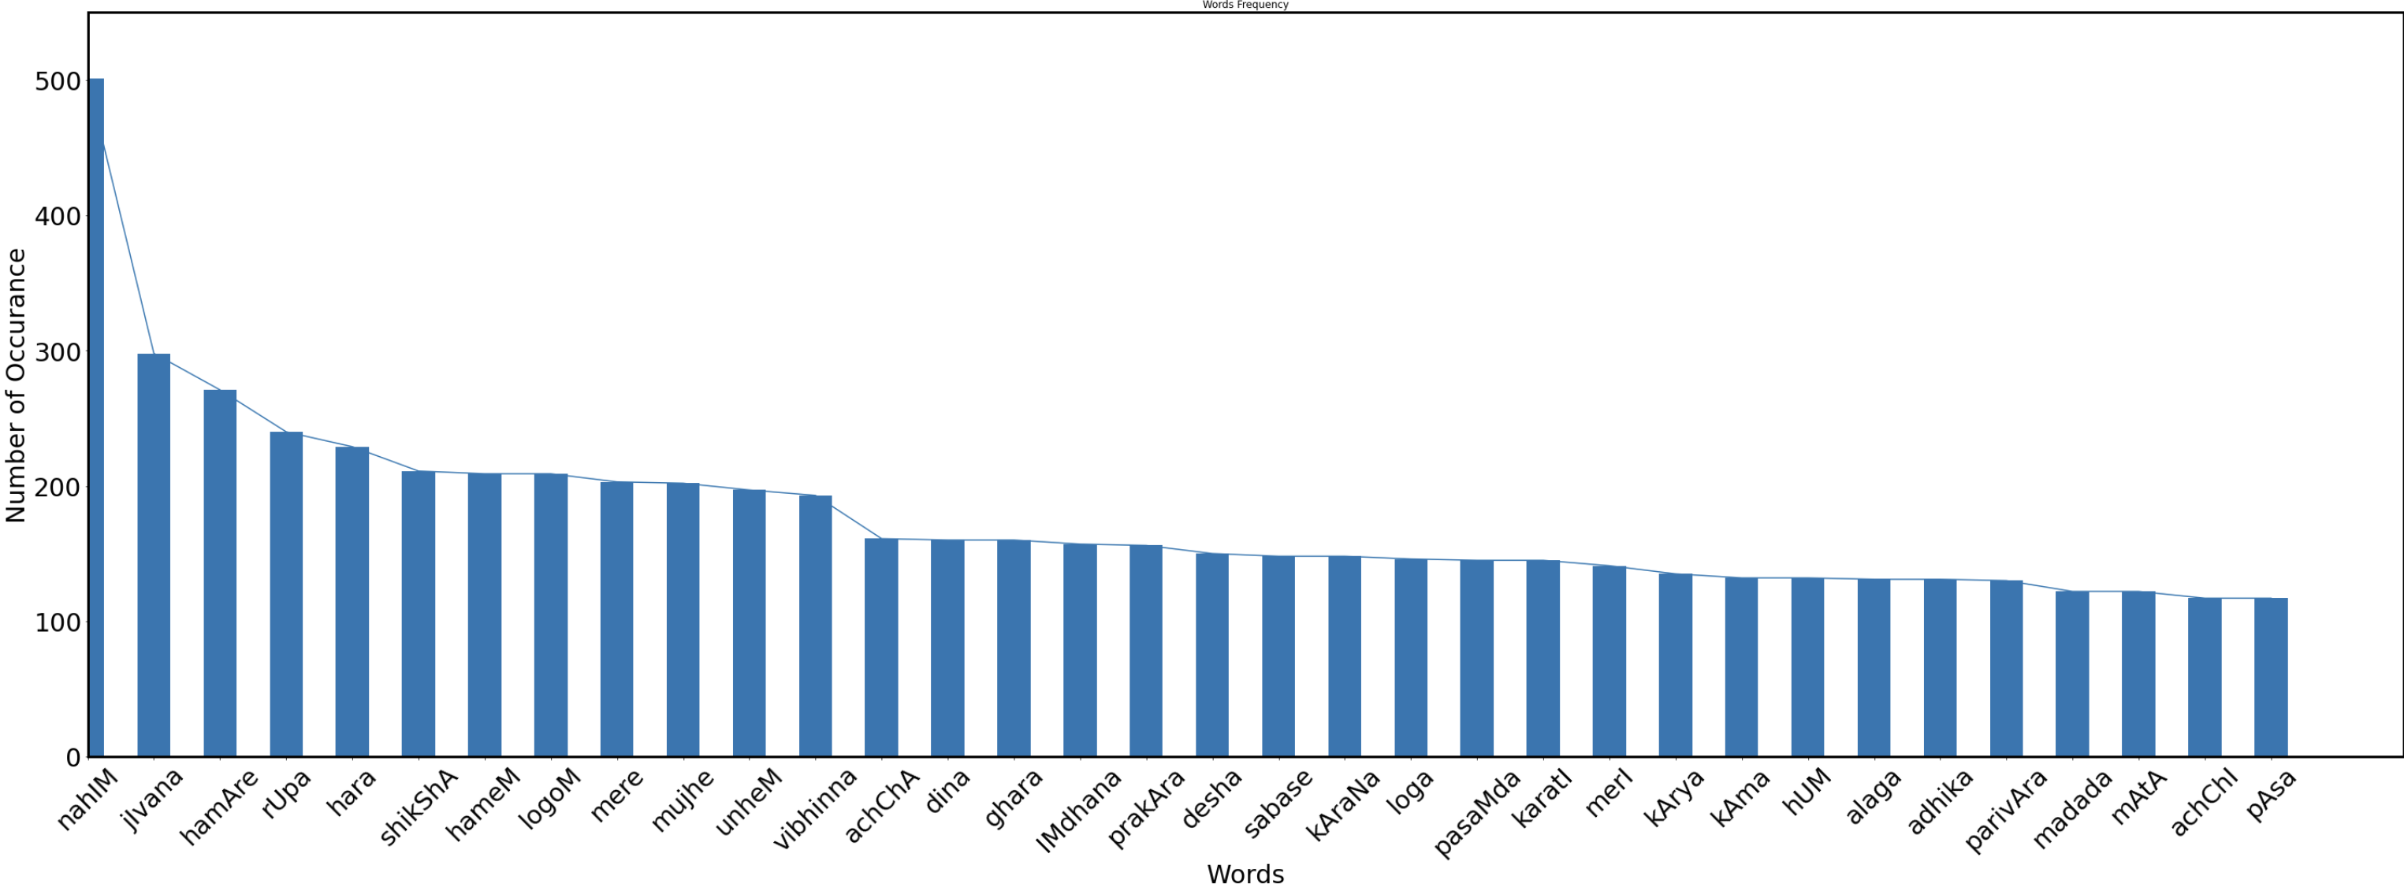

This is theGraph of Top 35 Words in Frequency.

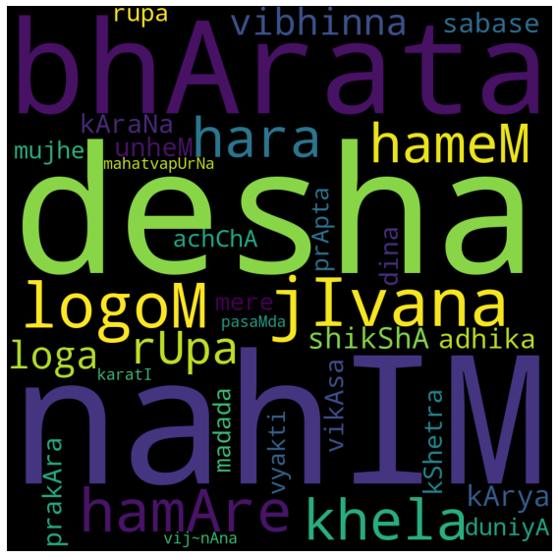

This made using the WordCloud Library.

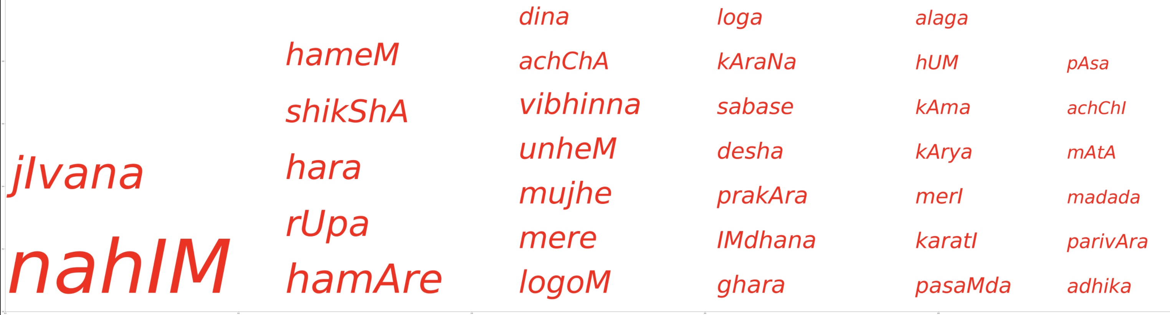

This is made using only MatplotLib using the number of Occurrence of these words and assigned a relative font size to these words and pointing them in this space.

**I took the first 35 words with most occurance in the corpus for the Word Cloud as it Represent the main Chunk of the corpus and hence they will represent oru corpus in the wordcloud.**

Here what I did is I assigned the font-Size of the Text as a Function of Frequency relative to the size of the plane printing the text.

**Overview of my Code:**

**Now I will explain how I did the processing**

**Step 1: I select a Hindi Website and scrape the text in <p> in that page only.**

**Step 2: I collected all the links in that website and iterated throught all links (Recursively i.e. links will be added with each link iteration) and added to the corpus**

**Step 3: I did Cleaning i.e. removing Extra Spaces, Puntuation marks, and changed everything to lower case in the corpus**

**Step 4: I Tokenized the corpus into Sentences Using iNLTK library by some rules I thought.**

**Step 5: Then I Tokenized into Words without any Library just by splitting by ‘ ’**

**Step 6: I cleaned the Words and Sentence again as I tokenized old corpus .**

**Step 7: I removed Stopwords by iterating though each word and comparing string with the stopword list.**

**Step 8: I did POS tagging using the StanfordNLP Library**

**Step 9: Then I did Stemming and Lemmatization using the Stanford Library.**

**Step 10: Then I made Graphs mentioned above.**